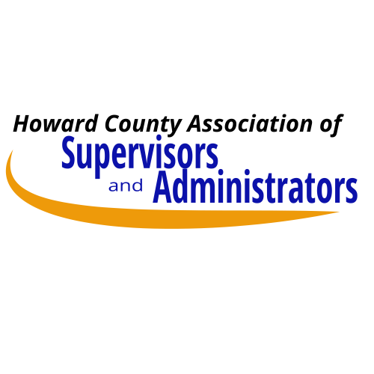

HCASA Sick Leave Bank Enrollment Form

2026-2027

Part A: Complete member information

Name: Employee ID #:

Position Title:

School or Building Location Name:

School or Building Mailing Address:

Part B: HCASA Sick Leave Bank Regulations Review

Please check to indicate that you have reviewed these two documents:

I have reviewed the HCASA Sick Leave Bank Regulations.

I have reviewed either the:

HCASA Admin Negotiated Agreement: Article 17, Sick Leave Bank or

HCASA NCS Negotiated Agreement: Article 18, Sick Leave Bank

Link: https://www.hcpss.org/employment/agreements-and-salaries/

Part C: Required Sick Leave Days

Contribution - I am authorizing the donation of two sick leave days to the HCASA Sick Leave Bank. Further donations the HCASA Sick Leave Bank may be required in future years.

Signature: Date:

Please return as an attachment to an email sent to:

Sharon Kramer, HCASA Executive Director

Sharon_Kramer@hcpss.org

